16 Channel Multifunction RS485 Module commamd
This product supports two kinds of instructions, AT command (ASCII code) and MODUBS RTU command (HEX format).
Automatic recognition of two kinds of commamds,no need to switch..

AT command (ASCII characters)

Note:
1 In the AT command mode slave ID is invalid
2 AT commands must be uppercase, lowercase invalid
9600 Band ,8 Data bits,None Parity,1 Stop Bit

Read Status:
Channel 1: AT+R1
Channel 2: AT+R2
Channel 3: AT+R3
Channel 4: AT+R4
Channel 5: AT+R5
Channel 6: AT+R6
Channel 7: AT+R7
Channel 8: AT+R8
Channel 9 ：AT+R9
Channel 10：AT+RA
Channel 11：AT+RB
Channel 12：AT+RC
Channel 13：AT+RD
Channel 14：AT+RE
Channel 15：AT+RF
Channel 16：AT+RG

Open :
Channel 1 : AT+O1
Channel 2 : AT+O2
Channel 3: AT+O3
Channel 4: AT+O4
Channel 5: AT+O5
Channel 6: AT+O6
Channel 7: AT+O7
Channel 8: AT+O8
Channel 9 ：AT+O9
Channel 10：AT+OA
Channel 11：AT+OB
Channel 12：AT+OC
Channel 13：AT+OD
Channel 14：AT+OE
Channel 15：AT+OF
Channel 16：AT+OG

Close:
Channel 1 : AT+C1
Channel 2 : AT+C2
Channel 3 : AT+C3
Channel 4 : AT+C4
Channel 5: AT+C5
Channel 6: AT+C6
Channel 7: AT+C7
Channel 8: AT+C8
Channel 9 ：AT+C9
Channel 10：AT+CA
Channel 11：AT+CB
Channel 12：AT+CC
Channel 13：AT+CD
Channel 14：AT+CE
Channel 15：AT+CF
Channel 16：AT+CG

Toggle (Self-locking)
Channel 1: AT+T1
Channel 2: AT+T2
Channel 3: AT+T3
Channel 4: AT+T4
Channel 5: AT+T5
Channel 6: AT+T6
Channel 7: AT+T7
Channel 8: AT+T8
Channel 9 ：AT+T9
Channel 10：AT+TA
Channel 11：AT+TB
Channel 12：AT+TC
Channel 13：AT+TD
Channel 14：AT+TE
Channel 15：AT+TF
Channel 16：AT+TG

Latch (Inter-locking)
Channel 1: AT+L1
Channel 2: AT+L2
Channel 3: AT+L3
Channel 4: AT+L4
Channel 5: AT+L5
Channel 6: AT+L6
Channel 7: AT+L7
Channel 8: AT+L8
Channel 9 ：AT+L9
Channel 10：AT+LA
Channel 11：AT+LB
Channel 12：AT+LC
Channel 13：AT+LD
Channel 14：AT+LE
Channel 15：AT+LF
Channel 16：AT+LG

Momentary (Non-locking)
Channel 1: AT+M1
Channel 2: AT+M2
Channel 3: AT+M3
Channel 4: AT+M4
Channel 5: AT+M5
Channel 6: AT+M6
Channel 7: AT+M7
Channel 8: AT+M8
Channel 9 ：AT+M9
Channel 10：AT+MA
Channel 11：AT+MB
Channel 12：AT+MC
Channel 13：AT+MD
Channel 14：AT+ME
Channel 15：AT+MF
Channel 16：AT+MG

Delay
Channel 1: AT+D1=XXXX
Channel 2: AT+D2=XXXX
Channel 3: AT+D3=XXXX
Channel 4: AT+D4=XXXX
Channel 5: AT+D5=XXXX
Channel 6: AT+D6=XXXX
Channel 7: AT+D7=XXXX
Channel 8: AT+D8=XXXX
Channel 9：AT+D9=XXXX
Channel 10：AT+DA=XXXX
Channel 11：AT+DB=XXXX
Channel 12：AT+DC=XXXX
Channel 13：AT+DD=XXXX
Channel 14：AT+DE=XXXX
Channel 15：AT+DF=XXXX
Channel 16：AT+DG=XXXX

XXXX refers to the 0000 to 9999 figures, Unit is seconds

All Relays Open
AT+AO

All Relays Close
AT+AC

Return command : OpenX, CloseX (X = 1/2/3/4..a/B/C/D/E/F/G)

Example 1:
Send command "AT+D1=0010", Channel 1 is "Open", after delay of 10 seconds, channel 1 is "Close"
Send command "AT+D2=0100", Channel 2 is "Open", after delay of 100 seconds, channel 2 is "Close"

Example 2:
Send command "AT+L1", Channel 1 is "Open", other Channels is "Close"
Send command "AT+L2", Channel 2 is "Open", other Channels is "Close"

MODBUS command (function code 06 is Control command,03 is Read status command)

Note :
1 MODBUS command must be HEX
2 Slave ID (device address) must be correct, the default slave address is 01.
3 If you don't remember the Slave ID, use the command Read Slave ID : FF 03 00 FF 00 01 A1 E4

9600 Band ,8 Data bits,None Parity,1 Stop Bit。
MODBUS 06 Command (Control command ,HEX):
Bytes Number | 1 | 2 | 3 | 4 | 5 | 6 | 7 | 8
MODBUS Definitions | Slave ID | Function | Address |  | Data |  | CRC Check
Function | Device Address | Function | Channel number |  | Command | Delay time | CRC Check
Open | 0x00-0xFE | 0x06 | 0x0001-  0x0010 |  | 0x01 | 0x00 | 2Bytes CRC
Close | 0x00-0xFE | 0x06 | 0x0001-  0x0010 |  | 0x02 | 0x00 | 2Bytes CRC
Toggle (Self-locking) | 0x00-0xFE | 0x06 | 0x0001-  0x0010 |  | 0x03 | 0x00 | 2Bytes CRC
Latch Inter-locking) | 0x00-0xFE | 0x06 | 0x0001-  0x0010 |  | 0x04 | 0x00 | 2Bytes CRC
Momentary (Non-locking) | 0x00-0xFE | 0x06 | 0x0001-  0x0010 |  | 0x05 | 0x00 | 2Bytes CRC
Delay | 0x00-0xFE | 0x06 | 0x0001-  0x0010 |  | 0x06 | 0x00-0xff | 2Bytes CRC
Open all | 0x00-0xFE | 0x06 | 0x0000 |  | 0x07 | 0x00 | 2Bytes CRC
Close all | 0x00-0xFE | 0x06 | 0x0000 |  | 0x08 | 0x00 | 2Bytes CRC
Baud rate | 0x00-0xFE | 0x06 | 0x00FE |  | 0x00 | 0x00-0x05
Slave ID(Device Address) | 0x00-0xFE | 0x06 | 0x00FF |  | 0x00 | 0x00-0xfe
Remarks:
1 Momentary mode, delay time is 1 seconds
2 Delay mode, delay time is 0-255 seconds

Return command：
Command is active, return to send commands; instruction is invalid no return.

MODBUS 03 Command (Read status command ,HEX):
Bytes Number | 1 | 2 | 3 | 4 | 5 | 6 | 7 | 8
MODBUS Definitions | Slave ID | Function | Address |  | Data |  | CRC Check
Function | Device Address | Function | Starting register address |  | Register length |  | CRC Check
Read Channel 1 State | 0x00-0xFE | 0x03 | 0x0001 |  | 0x0001
Read Channel 2 State | 0x00-0xFE | 0x03 | 0x0002 |  | 0x0001
Read 2 consecutive channels status | 0x00-0xFE | 0x03 | 0x0001-0x0003 |  | 0x0002
Read 3 consecutive channels status | 0x00-0xFE | 0x03 | 0x0001-0x0002 |  | 0x0003
Read 16 consecutive channels status | 0x00-0xFE | 0x03 | 0x0001 |  | 0x0010
Baud rate | 0x00-0xFE | 0x03 | 0x00FE |  | 0x0000-0x0005
Slave ID(Device Address) | 0xFF | 0x03 | 0x00FF |  | 0x0000-0x00fe

Read status command returns (function code 03, HEX format):
Bytes length | 1 | 1 | 1 |  | 2
MODBUS Definitions | Slave ID | Function | data length | data | CRC16 Check
Function | Device Address | Function | data length | Relay state  0x0001 open  0x0000 close | CRC16 Check
Channel 1  open | 0x00-0xFE | 0x03 | 0x02 | 0x0001
Channel 1  close | 0x00-0xFE | 0x03 | 0x02 | 0x0000
Channel 2  open | 0x00-0xFE | 0x03 | 0x02 | 0x0001
Channel 2  close | 0x00-0xFE | 0x03 | 0x02 | 0x0000
Channel 1 open  Channel 2 open | 0x00-0xFE | 0x03 | 0x04 | 0x0001 0x0001
Channel 1 open  Channel 2 close | 0x00-0xFE | 0x03 | 0x04 | 0x0001 0x0000
Channel 1 close  Channel 2 open | 0x00-0xFE | 0x03 | 0x04 | 0x0000 0x0001
Channel 1 close  Channel 2 close | 0x00-0xFE | 0x03 | 0x04 | 0x0000 0x0000

MODBUS commands you can use "Modbus Poll" input, as shown below
（CRC check generated automatically）
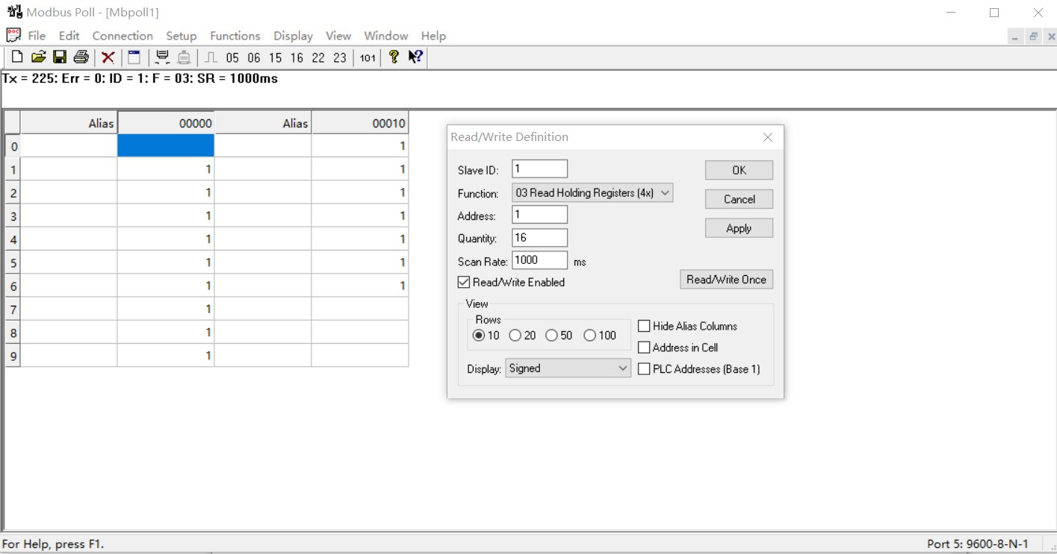
You can also use HyperTerminal serial input, as shown below
（Manually add CRC check）
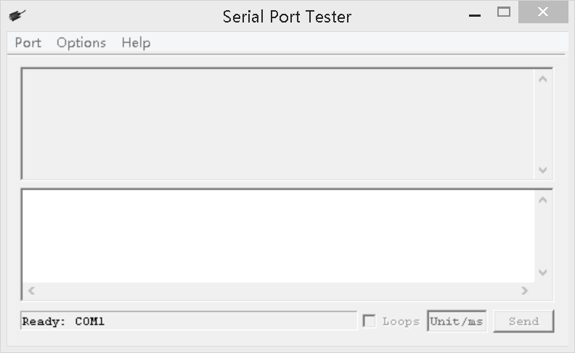

Examples (Slave ID is 1)
Channel 1 Open ：01 06 00 01 01 00 D9 9A
Channel 1 Close ：01 06 00 01 02 00 D9 6A
Channel 1 Toggle：01 06 00 01 03 00 D8 FA
Channel 1 Latch：01 06 00 01 04 00 DA CA
Channel 1 Momentary: 01 06 00 01 05 00 DB 5A
Channel 1 Delay 10 seconds : 01 06 00 01 06 0A 5B AD
Channel 1 Delay 100 seconds: 01 06 00 01 06 64 DA 41

Channel 2 Open ：01 06 00 02 01 00 29 9A
Channel 2 Close ：01 06 00 02 02 00 29 6A
Channel 2 Toggle ：01 06 00 02 03 00 28 FA
Channel 2 Latch ：01 06 00 02 04 00 2A CA
Channel 2 Momentary : 01 06 00 02 05 00 2B 5A
Channel 2 Delay 10 seconds : 01 06 00 02 06 0A AB AD
Channel 2 Delay 100 seconds : 01 06 00 02 06 64 2A 41

Open all：01 06 00 00 07 00 8B FA
Close all：01 06 00 00 08 00 8E 0A

Read state (assuming that the channel 1 is open, the channel 2 is close).
Read channel 1 state ：01 03 00 01 00 01 D5 CA
Return open：01 03 02 00 01 79 84

Read channel 2 state ：01 03 00 02 00 01 25 CA
Return close：01 03 02 00 00 B8 44

Read channel 1 and channel 2 state ：01 03 00 01 00 02 95 CB
Return channel open and channel 2 close ：01 03 04 00 01 00 00 AB F3

Read channel 1-16 state： 01 03 00 01 00 10 15 C6
Returns all channel states (all open)：01 03 20 00 01 00 01 00 01 00 01 00 01 00 01 00 01 00 01 00 01 00 01 00 01 00 01 00 01 00 01 00 01 00 01 AF 0C
Returns the status of all channels (all closed)：01 03 20 00 00 00 00 00 00 00 00 00 00 00 00 00 00 00 00 00 00 00 00 00 00 00 00 00 00 00 00 00 00 00 00 92 7A

Set the baud rate
- Read baud rate
Send data
Slave ID(Device Address)  (1) | Function (1) | Register address (2) | Read number (2) | CRC16(2)

Returns data
Slave ID(Device Address)  (1) | Function (1) | Number of bytes (1) | data (n) | CRC16(2)

Function code 0x03
Slave ID : 0x01~0xFE
Register address：0x0003
Read number：0x0001
For example:
send data(Slave ID is 1)：01 03 00 FE 00 01 E5 FA
Returns data：01 03 02 00 03 F8 45
01 RS485 address，03 Function，02 length，F8 45 crc16
03 means the current baud rate is 9600bps
Baud rate corresponds to the number: 0: 1200 1: 2400 2: 4800 3: 9600 4: 19200

- Write baud rate
Send data
Slave ID(Device Address)  (1) | Function (1) | Register address (2) | Setting Content (2) | CRC16(2)

Returns data
Slave ID(Device Address)  (1) | Function (1) | Register address  (2) | Register value (2) | CRC16(2)

Function code 0x06
Slave ID : 0x01~0xFE
Register address：0x00FE
Setting Content：2Bytes(0-4)

For example, Change the baud rate to 4800bps:
send data(Slave ID is 1)：01 06 00 FE 00 02 69 FB
Returns data：01 06 00 FE 00 02 69 FB
Baud rate corresponds to the number: 0: 1200 1: 2400 2: 4800 3: 9600 4: 19200
5: Factory reset
Note: 1 The baud rate will be updated when the module is powered up again!
2 The factory setting can be restored when the baud rate corresponding to the number is 5. For example: 01 06 00 FE 00 05 28 39

Set Slave ID(Device Address)

- Read Slave ID
Send data
Slave ID  (Broadcast address)  (1) | Function (1) | Register address (2) | Read number (2) | CRC16(2)

Returns data
Slave ID  ( Broadcast address )  (1) | Function (1) | Number of bytes (1) | data (n) | CRC16(2)

Broadcast address 0xff
Function code 0x03
Register address：0x00FF
Read number：0x0001

For example:
send data：FF 03 00 FF 00 01 A1 E4
Returns data：FF 03 02 00 01 50 50
FF Broadcast address，03 Function，02 length，01 is the current module Slave ID, 50 50 crc16
Note: When using this command, only one temperature module can be connected to the RS485 bus, more than one will be wrong!

- Write Slave ID
Send data
Slave ID  ( Device Address )  (1) | Function (1) | Register address (2) | Setting Content (2) | CRC16(2)

Returns data
Slave ID  ( Device Address )  (1) | Function (1) | Register address  (1) | Register value (2) | CRC16(2)

Function code 0x06
Register address：0x00FF
Setting Content：2Bytes(1-247)

For example, The current Slave ID is 1, We need to change the Slave ID to 3:
Send data(Slave ID is 1)：01 06 00 FF 00 03 F9 FB
Returns data：01 06 00 FF 00 03 F9 FB

